**IT5505**

**Interaction Design Fundamentals**

Trimester 2

Journal Assignment 2

Name: Adya Sinha

Student ID: 2230449

Submission Date:

Table of Contents

**No table of contents entries found.**

# Navigation Bar Prototypes

# Prototype 1

# Prototype 2

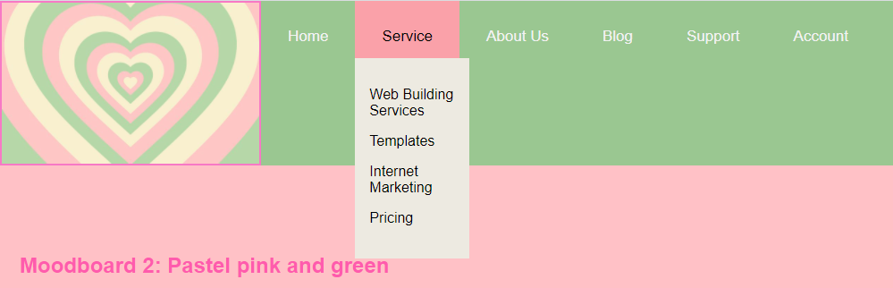

# Prototype 3

